**LAB REPORTS**



**Session 2023-2027**

**Submitted by:**

Sumaira Hafeez 2023-CS-1

**Supervised by:**

Dr. Faiza

**Course:**

Information Security

**Department of Computer Science**

**University of Engineering and Technology,**

**Lahore Pakistan**

Contents

**TASK 3 EXPLORING THREAT AGENTS** 3

**1.** **Metasploit Framework:** 3

**2.** **Process Followed:** 3

• **msfconsole:** 3

• **Exploit:** 3

**3.** **CONCLUSION:** 6

# **TASK 4 EXPLORING THREAT AGENTS**

## **Metasploit Framework:**

This report presents an analysis of threat agents to exploit the vulnerabilities in a system using Metasploit Framework.

## **Process Followed:**

### **msfconsole:**

It opens interface for Metasploit Framework. After that search command is used to search for exploiting vulnerabilities.

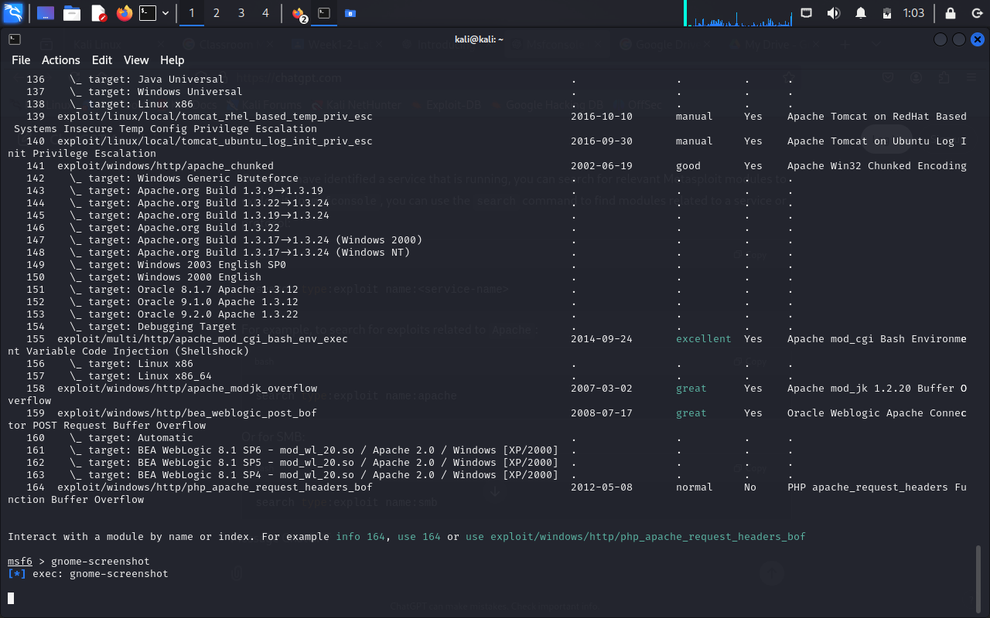

### **Exploit:**

After exploiting the specific path it provides all the data related to that path where you can exploit its vulnerabilities.

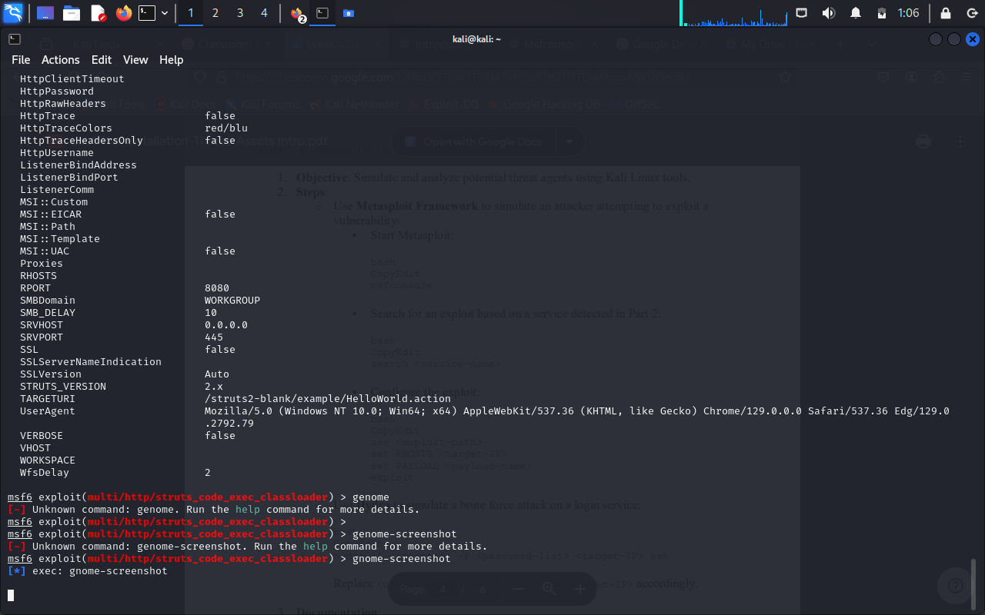

* **RHOSTS:**

It is used to specify target host or network range for an exploit It defines the systems you want to attack or test against.

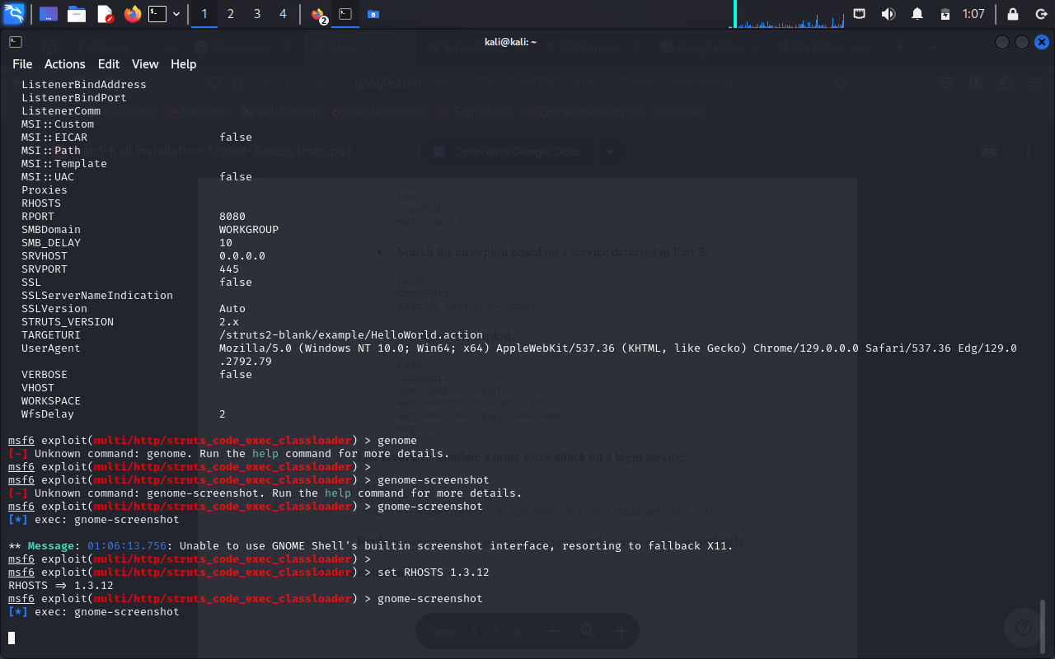

* **PAYLOAD:**

The payload command in Metasploit is used to specify the type of payload that will be delivered to the target system during an exploit.

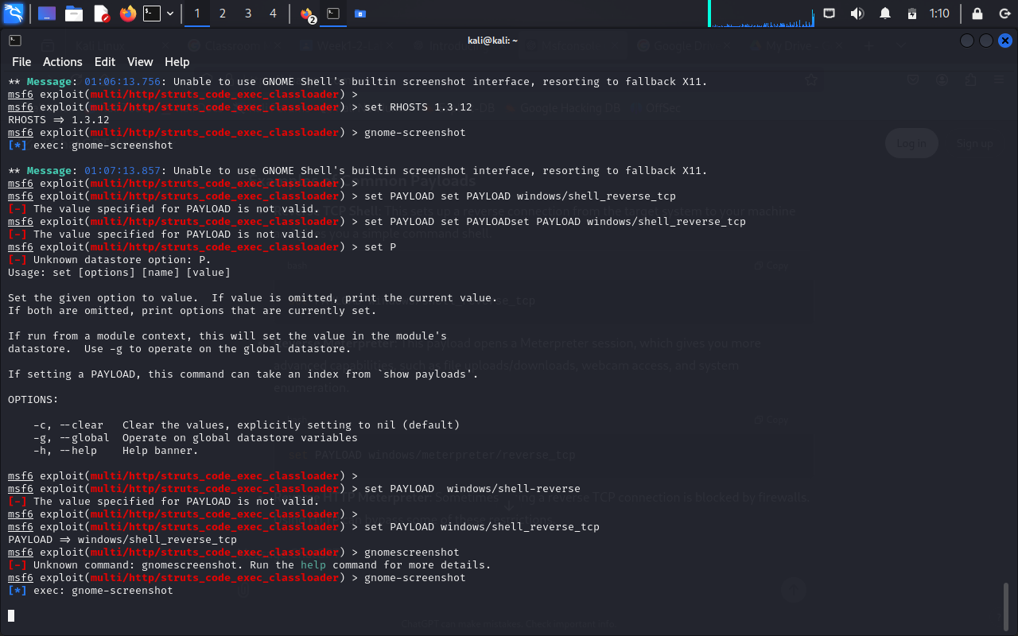

# **CONCLUSION:**

The vulnerability research identified critical security risks in the software infrastructure. Immediate remediation actions are recommended to address high-risk vulnerabilities. Implementing long-term security best practices will further strengthen the system’s resilience against cyber threats.